FreshAir Desk: AI-Powered Smart Desk Environment Monitor
T. Divya Darshini, S. Santhosh Kumar, Bangalathota Navyasree, S.M. Sowmiya
Department of Computer Science and Engineering
Vels Institute of Science, Technology and Advanced Studies (VISTAS)
T. Divya Darshini | darshudivya28@gmail.com
S. Santhosh Kumar | santhoshsiva4745@gmail.com
Bangalathota Navyasree | bangalathotanavyasree@gmail.com
Sowmiya S. M. | smsowmiya.se@vistas.ac.in

Abstract— Indoor environmental quality can affect health, comfort, concentration, and productivity; however, changes in air conditions, temperature, and humidity may go unnoticed by people who spend long hours indoors. This study presents FreshAir Desk, an ESP32-based desk environment monitor using DHT22, BH1750, and MQ135 sensors. It reports temperature, humidity, light intensity, and MQ135 resistance readings (RS and RS/R0) on a live laptop dashboard with status labels and a short history. A rule-based classifier labels conditions as Good, Attention, or Poor and displays fixed, condition-linked suggestions. An implemented AI Insights panel uses the sensor readings to generate a summary, practical suggestions, an overall score, and a focus-impact statement. The AI output is advisory, and software refinements are ongoing to improve consistency between generated insights and the dashboard status. The supplied comparison tables cover small and large rooms and classrooms, in air-conditioned and naturally ventilated settings, at different occupancy levels. The listed values show differences across these scenarios, including higher temperature and humidity values in the naturally ventilated cases. The supplied comparisons are descriptive and are not presented as a controlled validation study; they do not establish that occupancy or cooling alone caused the differences. FreshAir Desk brings environmental readings and their rule-based interpretation together in one interface for user awareness.
Index Terms—Internet of Things, ESP32, environmental monitoring, smart desk, MQ135, rule-based classification, AI-generated insights, occupancy comparison.
I. INTRODUCTION
A. Motivation
People who study or work at a desk spend long periods in an indoor environment whose temperature, humidity, illumination, and air conditions can vary. When these conditions are not monitored together, changes may be difficult to detect through casual observation. Prior work in the supplied literature survey describes IoT monitoring of indoor thermal and air conditions, multi-sensor smart-building systems, and data-driven approaches to selected indoor-air questions [1]–[4]. Such studies motivate accessible local monitoring, while their particular models and measurements should not be assumed for a smaller desk prototype.
A desk monitor has a different practical focus from a building-management installation. Its measurements are intended to

make conditions near one workstation visible in a form that can be read while the user is working. The system described
here is not an automated controller for heating, ventilation, or lighting. Its purpose is to collect the selected environmental readings and make their current interpretation available to the user through a laptop display. Several distinctions matter when describing such a device. A sensor value is an observation from a sensing element; an interpreted condition is the output of the project’s decision rules; and a measure of health, comfort, or productivity would require a separate definition and evidence. FreshAir Desk currently reports the first two types of information. It does not calculate a human comfort or focus score, and no productivity effect is evaluated in the supplied project material.
The need for a compact monitoring system can also be framed as a visibility problem. When a user cannot see several environmental measurements together, they may not know whether a change is associated with temperature, light, humidity, or the gas-sensing channel. A multi-sensor display can bring these observations into one place. Whether this view leads to a change in user behavior is a separate research question and is not measured by the current prototype description.
B. Project Scope
FreshAir Desk brings four confirmed sensing channels into one ESP32-based prototype: temperature and humidity, ambient illuminance, and MQ135 gas-sensing readings. The dashboard runs on a laptop and presents live values alongside the rule-based classification and AI Insights. The software implementation is operational, including live readings, rule-based labels, and AI-generated summaries and suggestions. Refinements are in progress to correct occasional inconsistencies in generated insights; these are output-quality refinements to a working system.
The current implementation uses the DHT22, BH1750, MQ135, ESP32, and a live laptop dashboard. It does not include noise sensing or a comfort score. Classification is rule-based. Condition-linked fixed dashboard hints remain part of the interface; separately, the AI Insights panel generates a summary, practical suggestions, an overall numeric score, and a focus-impact statement from sensor readings. The displayed overall score is an AI output, not a comfort score.
The available project materials also do not specify threshold values, a complete list of classification labels, a sampling interval, or the communications protocol between the controller and the laptop. These omissions are treated as documentation limits. The paper therefore explains the sequence of processing without assigning particular thresholds or claiming a specific network or serial implementation.
C. Contributions and Paper Organization
This paper describes the confirmed hardware and software path, the current rule-based dashboard and its integrated AI Insights layer, and the supplied live and comparative data. Section II reviews related work; Section III explains the system; Section IV presents the dashboard and comparative scenarios; and the remaining sections cover implementation, limitations, and conclusions.
II. RELATED WORK
The supplied literature survey covers several strands of indoor-environment research. Shriram et al. describe IoT monitoring of thermal conditions and indoor air quality [1]. Gabriel and Auer discuss machine-learning estimation of indoor air pollution [3], while Fanti et al. describe an IoT smart-building approach that includes indoor management and occupant prediction [6]. Bakare and Abubaker report a multi-parameter ESP32-WROOM monitoring architecture [8]. These works differ in sensors, deployment scale, and analytical approach; their reported performance values are not transferred to FreshAir Desk.
The conference studies in the supplied survey illustrate different system goals. The work by Shriram et al. addresses thermal comfort and indoor-air monitoring in workspaces, with real-time sensing as a practical advantage and a restricted set of environmental parameters as a stated limitation [1]. Praveenraja and Manitha combine air and sound pollution monitoring with HVAC integration [2]. That work concerns monitoring coupled to building control, whereas FreshAir Desk provides a local dashboard and has no confirmed HVAC control or noise channel.
Gabriel and Auer apply artificial neural networks and support-vector regression to indoor-air-pollution estimation [3]. Yeom, Kim, and Yoon consider productivity prediction using environmental conditions together with physiological signals [4]. These studies show how a measurement system can be extended with predictive targets, but those targets require algorithms and input data beyond the simple rule-based interpretation implemented in FreshAir Desk. No prediction model or physiological input is part of the current project.
Cicceri et al. use air-quality sensing to estimate room headcount [5]. The study shares an interest in deriving a higher-level condition from sensor data, but its occupancy objective is distinct from a desk-side environmental classification. Fanti et al. describe indoor-environment management and occupant prediction in an IoT smart-building setting [6], while the 2023 comparison of intelligent and traditional buildings examines indoor environmental quality alongside self-reported productivity [7]. The latter concerns relationships assessed in buildings; FreshAir Desk has no user survey or productivity measurement in its supplied project results.
Bakare and Abubaker provide the closest hardware-level point of comparison in the supplied literature: an ESP32-WROOM-based multi-parameter indoor monitoring architecture [8]. Their paper reports a particular sensor suite, communications approach, and experimental results. Those details belong to that study and are not adopted as properties of FreshAir Desk. The present prototype has its own confirmed sensor set and laptop display, and its project materials do not report equivalent calibration or performance experiments.
Taken together, the reviewed sources cover monitoring, building control, air-quality estimation, occupancy inference, and productivity analysis. FreshAir Desk occupies a narrower implementation point: multiple environmental readings are collected by a low-cost controller, interpreted through rules, and presented live to a laptop user. The contribution documented here is an account of that integration and its current scope, not a claim that it outperforms or replaces the larger systems in the literature.
A useful way to compare these studies is by the output they target. Some report measurements for awareness; others infer a hidden state such as occupancy, estimate a future value, or connect measurements to environmental control. The choice of output changes the data and validation needs of a system. FreshAir Desk currently uses a direct, rule-based condition label. It does not attempt the predictive or personalized outputs described in several of the reviewed studies, and it should be evaluated according to its own narrower purpose.
The distinction between measurement and inference is especially relevant to this comparison. Monitoring a value does not by itself establish a cause or a health effect. Estimating a pollutant, predicting productivity, or inferring occupancy introduces an additional analytical target, each with separate input and validation requirements. The FreshAir Desk rule output is simpler: it summarizes readings according to conditions selected for the prototype. Keeping that output modest makes the project easier to explain and avoids implying that it performs the more complex analyses covered in the literature.
The literature survey also highlights why claims should be tied to the implementation. The reviewed works use different sensors, contexts, and methods, so the advantages reported for those systems cannot be transferred to this project. The FreshAir Desk project documents establish a sensor set and a dashboard flow, but not comparative testing against another monitor. Accordingly, the comparison here is conceptual and descriptive rather than quantitative.
Additional supplied sources discuss indoor environmental quality and occupant experience [9], [10], broader IoT air-monitoring systems [11], [22], [25], and educational or indoor deployments [12], [14], [15], [20], [23], [24]. Measurement-focused papers describe multi-sensor characterization and traceability [13], [16], [18], while systems-oriented studies address sensor networks, indoor monitoring design, and building integration [17], [19], [21], [26].
Other supplied work examines indoor environmental quality in living-lab, classroom, and regional settings [20], [23], [27], [28], [29]. A lighting-focused study provides context for illuminance as an indoor parameter [30]. These sources motivate the sensing topics and evaluation needs; their reported results are not measurements from FreshAir Desk.
Across the supplied literature, sensors, deployment conditions, and target outputs differ. FreshAir Desk is described according to its own confirmed components and current software behavior. The cited studies are not used as a performance benchmark for this prototype.
Table I summarizes the principal emphasis of the reviewed studies and their relation to this project. It is included to separate the research questions in the literature from the functionality currently implemented. The table is based on the short descriptions in the supplied survey; it does not attempt a new evaluation of the cited papers.
TABLE I. SUMMARY OF RELATED LITERATURE
Reference | Focus reported in the survey | Relation to FreshAir Desk
[1] | Thermal comfort and indoor air monitoring | Comparable sensing context; fewer parameters in the described project
[2] | Air and sound monitoring with HVAC integration | Building control and sound are outside current scope
[3] | Machine-learning estimation of indoor air pollution | Prediction is not implemented here
[4] | Productivity prediction with physiological signals | No wearable or productivity model in this project
[5] | Room headcount estimation from air-quality sensing | Occupancy is not a FreshAir Desk output
[6] | IoT building management and occupant prediction | Larger building-level application context
[7] | Indoor quality compared with self-reported productivity | FreshAir Desk has no user survey or productivity measure
[8] | ESP32 multi-parameter indoor monitoring | Closest controller-level comparison in supplied survey

FreshAir Desk is narrower in function. It combines the named sensors with a laptop dashboard and applies predefined rules to the current readings. The project materials confirm no machine-learning model, comfort or focus scoring, or noise-sensing component in the implemented system. This distinction keeps the description aligned with the prototype rather than with broader capabilities discussed in some of the reviewed papers.
III. SYSTEM DESIGN AND METHODOLOGY
The methodology is organized as a short processing chain: sensing, acquisition by the ESP32, preparation of the readings, rule evaluation, and presentation on the laptop dashboard. This sequence follows the supplied project methodology. It describes the functions assigned to the components without prescribing a communication protocol or execution rate that the project documents do not identify.
A. Hardware and Measurements
The ESP32 development board acts as the controller. The DHT22 provides temperature and relative-humidity readings; the BH1750 measures ambient light intensity; and the MQ135 provides gas-sensing readings. The current dashboard includes MQ135 sensor resistance (RS) and the RS/R0 ratio. These fields are presented as sensor readings and a ratio used by the project logic; no gas concentration or calibration accuracy is claimed here.
The sensors represent different aspects of the immediate desk environment. Temperature and relative humidity are delivered together by the DHT22. The BH1750 contributes an illumination measurement, which is displayed as light intensity. The MQ135 channel is represented by resistance-based values. Keeping the channels visible separately makes it possible to inspect the source readings before considering the classification produced by the rules.
The term “air-quality-related” is used cautiously for the MQ135 channel because the supplied FreshAir Desk materials identify it as an air-quality or gas-sensing sensor but do not provide an implemented conversion from RS/R0 to a named gas concentration. The paper therefore records the reported resistance values and ratio as they appear in the project, and does not state a parts-per-million value or infer a specific pollutant level.
Each sensor has a distinct role in the combined view. The DHT22 contributes two variables, so the dashboard should treat temperature and humidity as separate fields even though they originate from one module. The BH1750 contributes light intensity as its own field. The MQ135 channel contributes the resistance and ratio values that the project currently exposes. The ESP32 is the common acquisition point that brings those readings into the processing sequence.
Displaying the input fields separately also supports a clearer reading of the rule output. A single condition label can compress several observations into one summary, but the underlying values show which measurements are available to the user. This paper does not assume that every displayed value contributes to every rule, because the exact rule definitions are not present in the supplied files. The final firmware documentation should identify those links explicitly.
TABLE II. SENSOR AND DASHBOARD MEASUREMENT MAPPING
Component | Confirmed role | Dashboard information
DHT22 | Temperature and relative humidity | Temperature; humidity
BH1750 | Ambient light measurement | Light intensity
MQ135 | Gas sensing | RS and RS/R0
ESP32 | Sensor acquisition and processing | Feeds current values and classification
Laptop | Live dashboard display | Readings and rule-based condition

Figure 1 shows the sensor-to-measurement mapping confirmed for the prototype. The filled cells indicate which outputs originate from each sensor; the chart is categorical and does not represent measurement magnitude or accuracy.
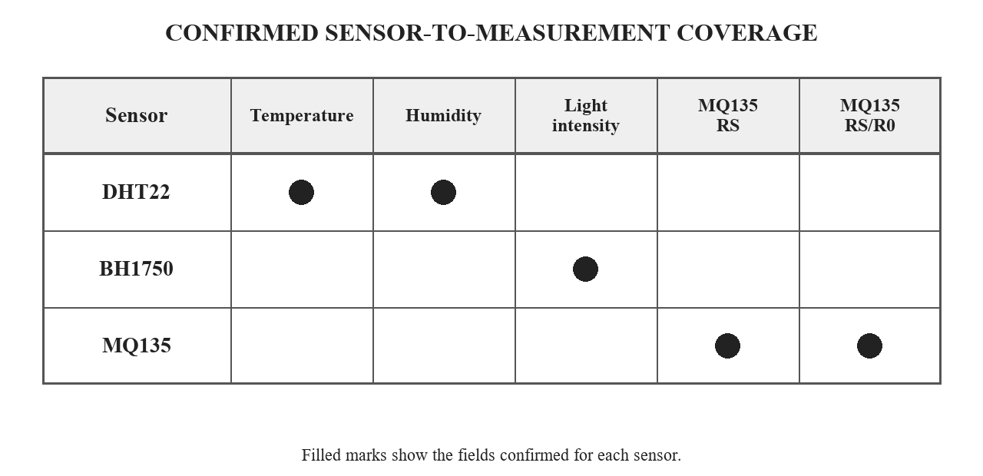
Fig. 1. Confirmed sensor-to-measurement coverage.
B. Data Path
The sensors provide their respective readings to the ESP32. The controller reads and organizes the values, applies the project’s rule-based conditions, and makes the current readings and interpreted condition available in the live laptop dashboard. Figure 2 summarizes this confirmed path. The project documentation does not state a sampling interval or a communications protocol, so neither is specified here.
At acquisition, each sensor contributes a value of a different kind and scale. The DHT22 yields a temperature and a humidity value, the BH1750 yields an illumination value, and the MQ135 contributes its resistance-based readings. Organizing the values by source and measurement name helps the interface keep the live observations distinct. The decision stage can then evaluate the conditions configured for the project without erasing the underlying readings that are useful for interpretation.
The architecture intentionally separates sensing from presentation. The ESP32 serves as the data-collection and processing element, while the laptop is the user-facing display. The available description confirms that the dashboard is live but does not establish whether updates use Wi-Fi, a serial connection, or another link. The figure consequently uses a generic data-flow arrow and should be read as a functional diagram, not a wiring schematic or network specification.
At a functional level, the measurement path can be understood as four linked responsibilities. Sensor modules produce readings; the controller makes those readings available to software; the processing logic evaluates their current values; and the dashboard communicates the result to the user. This decomposition helps describe the prototype even when detailed wiring and message formats are not specified. It also keeps the visual architecture independent of a particular transport implementation.
The architecture also provides a useful boundary for troubleshooting. If a value is absent from the display, the source of the issue could lie in sensor acquisition, controller-side preparation, transfer to the laptop, or dashboard presentation. A documented stage-by-stage check would help locate such an issue without conflating it with the classification rule itself. This is a design implication of the stated functional chain, not a claim that a particular fault has occurred.
Table III expresses this sequence in terms of its inputs, operations, and user-facing output. The sequence is based on the methodology document and the confirmed live dashboard. It does not state how often a step repeats, how the data are transported, or which internal data structure is used.
TABLE III. DATA PROCESSING SEQUENCE
Stage | Operation | Information produced
Acquire | Read DHT22, BH1750, and MQ135 | Temperature, humidity, light, RS, RS/R0
Organize | Collect and prepare current readings | Values for rule evaluation
Classify | Apply project-defined conditions | Current environmental condition
Present | Update the laptop dashboard | Live readings and condition

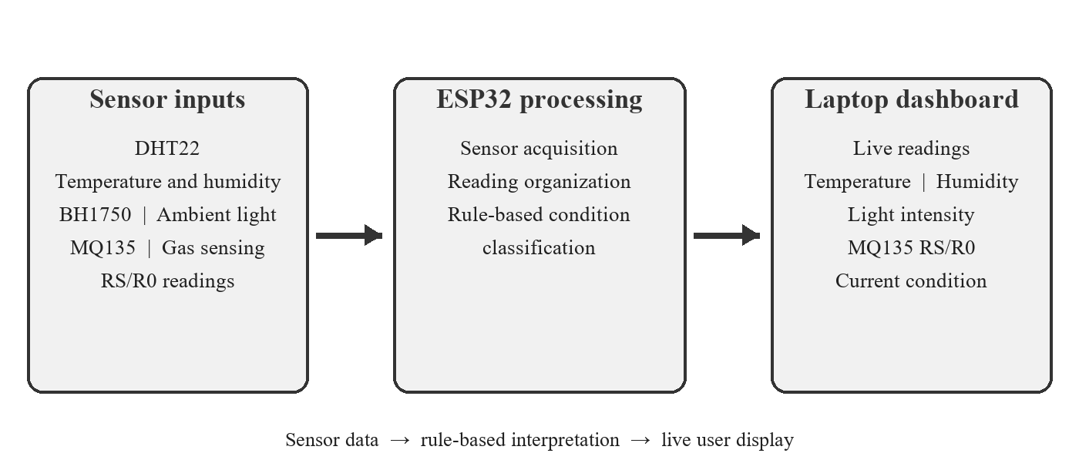
Fig. 2. Confirmed FreshAir Desk sensing, processing, and display flow.
The ordered processing stages are shown separately in Figure 3. The diagram restates the project methodology at a functional level; it does not add a particular communications protocol, threshold, or classification label.
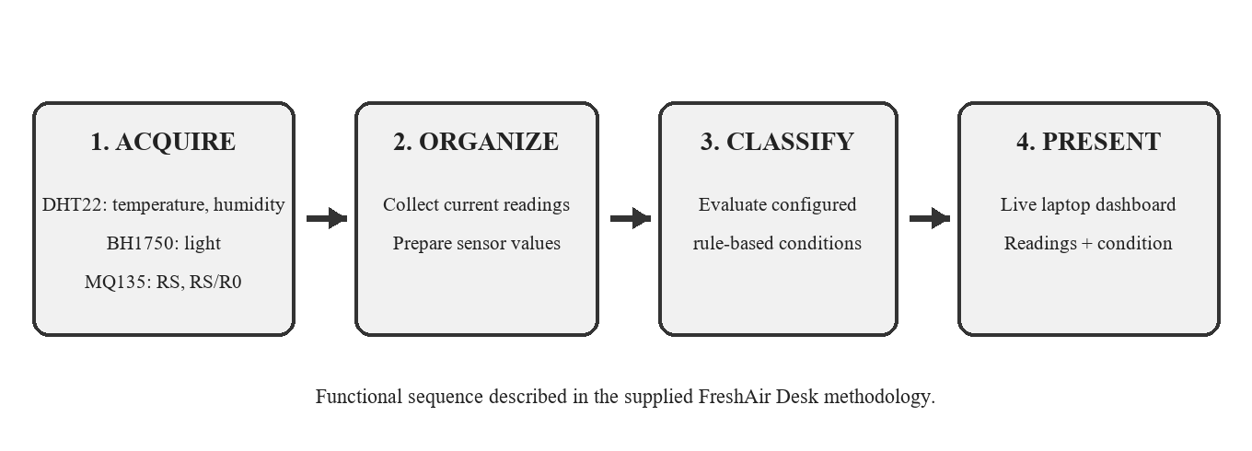
Fig. 3. Sensor acquisition, rule evaluation, and dashboard presentation.
C. Rule-Based Classification
The prototype uses predefined conditions to interpret the acquired environmental readings. The project materials do not specify the numerical cutoffs, the full set of output labels, or priority behavior when several conditions occur together. The algorithm below therefore expresses the confirmed processing sequence without inventing thresholds or decision outcomes.
In a rule-based design, an observed value is compared with conditions encoded by the developer, and the applicable condition determines a human-readable class or state. The important characteristic here is that the interpretation is defined by rules rather than learned from a training set. For FreshAir Desk, the project owner has confirmed that this rule-based approach is the one used. The exact predicates remain unavailable in the source documents, so this paper names the stages of the algorithm but does not substitute example ranges for the actual firmware values.
The classification should be interpreted as a summary of configured sensor conditions, not as a medical assessment or a direct measurement of personal comfort. The dashboard also displays an AI-generated overall score and focus-impact statement; these are generated outputs, not validated measures of human comfort, focus, or productivity. Such claims would require a separately defined model and evaluation.
The rule-based approach has a practical advantage for a prototype: its output is determined by explicit conditions rather than by fitting a model from a training corpus. That makes the decision path potentially straightforward to inspect once the final rule table is documented. The approach still depends on the quality and consistency of the inputs and on clear definitions of the rules. If several readings satisfy different conditions at once, a defined precedence or combination policy is needed to make the result reproducible.
Rule-based classification should not be confused with a fixed universal standard. A rule set encodes choices about boundaries and labels for a particular application. The project documents supplied for this paper confirm that rules are used, but do not give their complete values. This paper therefore does not prescribe what temperature, humidity, illumination, or RS/R0 values should count as a particular state. Those values belong in an implementation-specific methods description after they have been checked against the final code.
D. Reading Ratio
The MQ135 values include sensor resistance, RS, and a ratio of RS to R0. The ratio is expressed as:
r = RS / R0
Here, r denotes the displayed resistance ratio. The project materials confirm that RS and RS/R0 are shown, but they do not define the procedure used to establish R0 or describe a calibration against a reference gas. Consequently, the ratio is included as a system reading and is not converted here into a concentration or accuracy claim.
E. Processing Sequence
Algorithm 1 Rule-based environment classification
Input: current DHT22, BH1750, and MQ135 readings
1. Acquire temperature and relative humidity from DHT22.
2. Acquire ambient light intensity from BH1750.
3. Acquire MQ135 RS and RS/R0 readings.
4. Organize the readings for the current update.
5. Evaluate the configured project rules against the readings.
6. Provide the resulting condition and readings to the live laptop dashboard.
Output: current sensor values and rule-based condition
The thresholds and classification labels should be reported in a future revision once verified against the final firmware.
F. Dashboard Output
The live laptop dashboard presents temperature, relative humidity, light intensity, MQ135 RS, MQ135 RS/R0, and the current rule-based condition. It also shows fixed, condition-linked hints. A separate AI Insights panel uses current sensor readings and the overall condition to generate a short interpretation, practical suggestions, an overall score, and a focus-impact statement. The project server sends the readings to a Qwen model through the Groq service; the generated text is advisory and is being refined because it can occasionally conflict with the rule-based status shown beside it.
Keeping raw values visible alongside the condition label helps users distinguish observations from the rule output. The supplied screenshot shows current cards and a recent history table. Figure 5 plots the ten history rows visible in that screenshot; it is a transcription of the screenshot excerpt rather than a long-term trial.
The laptop dashboard is the point at which sensing and rule processing become visible to the user. Its live presentation supports observation of the current environment rather than long-term trend analysis, unless a separate recording function is later confirmed. No historical chart, data export, alert, or remote-access capability is assumed here. These distinctions prevent the general term “dashboard” from implying functions that have not been documented for this prototype.

G. AI Insights Generation
The AI Insights feature is implemented as a server-side service. It reads the current ESP32 data, including temperature, humidity, light, the MQ135 RS/R0 ratio, and the overall condition, then sends these values to the Qwen model through Groq. The model returns a short summary, practical suggestions, an integer overall score on a 1–10 scale, and a focus-impact statement in structured JSON for the dashboard. The dashboard also provides a Refresh Now control, and the server checks for changes in the overall condition to refresh the insight. These generated responses are distinct from the deterministic rule-based labels and fixed hints. They are advisory rather than validated health or productivity assessments, and refinements are ongoing to improve agreement between the generated text and the dashboard status. An example of the generated dashboard panel is shown in Fig. 5.
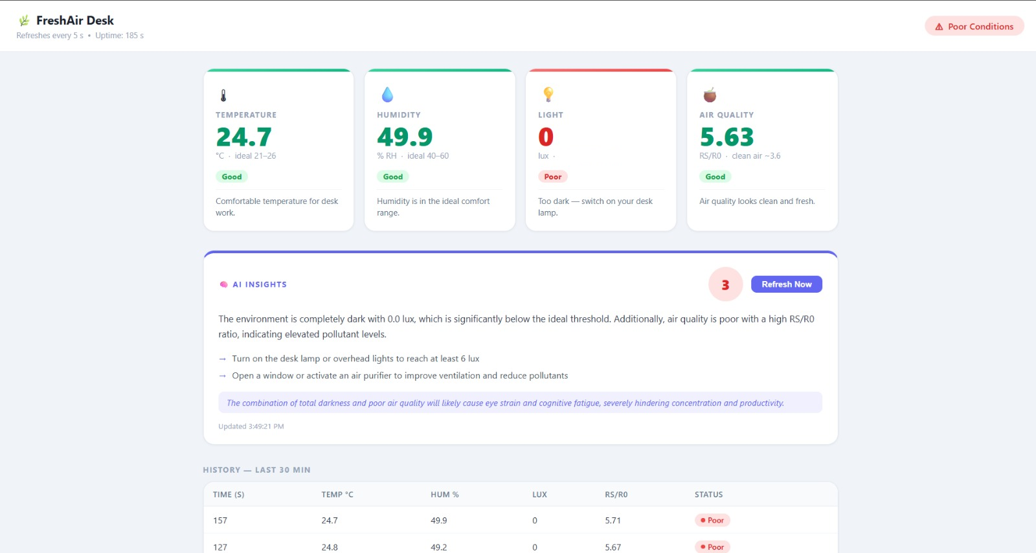
Fig. 4. Full dashboard showing live sensor readings and the AI Insights panel; example AI output is under refinement.

IV. DASHBOARD DATA AND COMPARATIVE SCENARIOS
The screenshot supplies one short history excerpt and current card values. The ten rows below are those legible in the image, ordered from oldest to newest; they are not a full 30-minute data export.
TABLE IV. TEN DASHBOARD HISTORY ROWS VISIBLE IN THE SUPPLIED SCREENSHOT
Time (s) | Temp. °C | RH % | Lux | RS/R0 | Status
246 | 34.6 | 65.5 | 10 | 3.03 | Poor
276 | 34.7 | 65.7 | 7 | 3.06 | Poor
306 | 34.7 | 65.5 | 10 | 3.12 | Poor
336 | 34.7 | 65.6 | 9 | 3.01 | Poor
366 | 34.7 | 65.2 | 9 | 3.13 | Poor
396 | 34.7 | 65.6 | 9 | 3.11 | Poor
426 | 34.6 | 65.5 | 22 | 3.45 | Poor
455 | 34.7 | 65.0 | 22 | 3.60 | Poor
485 | 34.7 | 64.9 | 20 | 3.61 | Poor
515 | 34.7 | 65.1 | 21 | 3.65 | Poor
In this excerpt, temperature and humidity change only slightly, while light and RS/R0 vary more. The displayed status is Poor for all ten visible rows. This is a short screenshot excerpt and does not explain why readings changed.
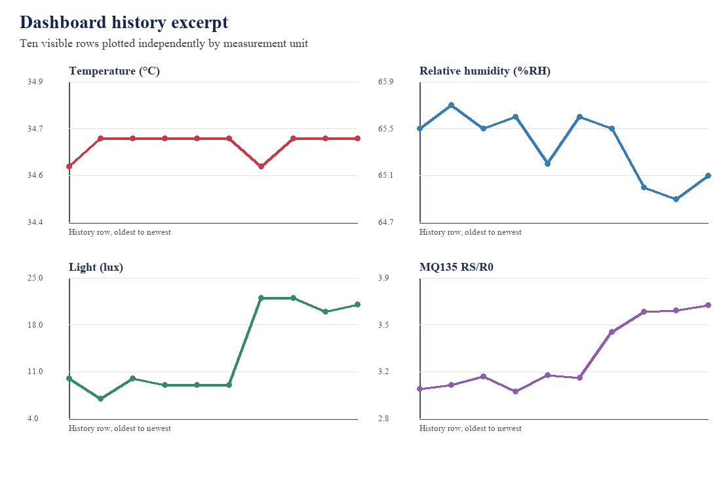
Fig. 5. Values across the ten visible history rows, plotted separately by unit.
The six supplied comparison images list values for three occupancy cases in each room or classroom setting. They are transcribed here as supplied scenario comparisons. The material does not include time-stamped raw logs or reference-instrument records for these cases, so the tables support descriptive comparison rather than a controlled validation study.

A. Air-Conditioned Small Room
TABLE V. AIR-CONDITIONED ROOM (SMALL ROOM) — OCCUPANCY COMPARISON
Parameter | 5 people | 10 people | 15 people
Room condition | Air-conditioned | Air-conditioned | Air-conditioned
Temperature (°C) | 24.5 | 25.4 | 26.3
Relative humidity (%RH) | 49.1 | 52.7 | 56.4
Light (lux) | 5.0 | 5.2 | 5.1
MQ135 RS/R0 | 4.15 | 3.35 | 2.58
Displayed condition | Good | Attention | Poor
Across the listed cases, the supplied values change with the occupancy points shown. Light remains near 5 lux. The entries are descriptive and do not establish that occupancy alone caused the changes.

B. Air-Conditioned Room (Big Room)
TABLE VI. AIR-CONDITIONED ROOM (BIG ROOM) — OCCUPANCY COMPARISON
Parameter | 10 people | 20 people | 30 people
Room condition | Air-conditioned | Air-conditioned | Air-conditioned
Temperature (°C) | 24.2 | 24.8 | 25.5
Relative humidity (%RH) | 48.6 | 50.9 | 53.4
Light (lux) | 5.1 | 5.0 | 5.2
MQ135 RS/R0 | 4.30 | 3.82 | 3.12
Displayed condition | Good | Good | Attention
Across the listed cases, the supplied values change with the occupancy points shown. Light remains near 5 lux. The entries are descriptive and do not establish that occupancy alone caused the changes.

C. Naturally Ventilated Room (Small Room)
TABLE VII. NATURALLY VENTILATED ROOM (SMALL ROOM) — OCCUPANCY COMPARISON
Parameter | 5 people | 10 people | 15 people
Room condition | Naturally ventilated | Naturally ventilated | Naturally ventilated
Temperature (°C) | 31.2 | 32.4 | 33.6
Relative humidity (%RH) | 63.5 | 67.8 | 72.1
Light (lux) | 5.0 | 5.1 | 5.2
MQ135 RS/R0 | 3.48 | 2.74 | 2.06
Displayed condition | Attention | Poor | Poor
Across the listed cases, the supplied values change with the occupancy points shown. Light remains near 5 lux. The entries are descriptive and do not establish that occupancy alone caused the changes.

D. Naturally Ventilated Room (Big Room)
TABLE VIII. NATURALLY VENTILATED ROOM (BIG ROOM) — OCCUPANCY COMPARISON
Parameter | 10 people | 20 people | 30 people
Room condition | Naturally ventilated | Naturally ventilated | Naturally ventilated
Temperature (°C) | 30.6 | 31.8 | 32.9
Relative humidity (%RH) | 62.0 | 65.7 | 69.5
Light (lux) | 5.2 | 5.0 | 5.1
MQ135 RS/R0 | 3.74 | 3.05 | 2.41
Displayed condition | Attention | Attention | Poor
Across the listed cases, the supplied values change with the occupancy points shown. Light remains near 5 lux. The entries are descriptive and do not establish that occupancy alone caused the changes.

E. Air-Conditioned Classroom
TABLE IX. AIR-CONDITIONED CLASSROOM — OCCUPANCY COMPARISON
Parameter | 20 people | 40 people | 60 people
Room condition | Air-conditioned | Air-conditioned | Air-conditioned
Temperature (°C) | 24.8 | 26.1 | 27.4
Relative humidity (%RH) | 50.2 | 54.8 | 59.6
Light (lux) | 5.0 | 5.1 | 5.0
MQ135 RS/R0 | 3.96 | 3.14 | 2.37
Displayed condition | Good | Attention | Poor
Across the listed cases, the supplied values change with the occupancy points shown. Light remains near 5 lux. The entries are descriptive and do not establish that occupancy alone caused the changes.

F. Naturally Ventilated Classroom
TABLE X. NATURALLY VENTILATED CLASSROOM — OCCUPANCY COMPARISON
Parameter | 20 people | 40 people | 60 people
Room condition | Naturally ventilated | Naturally ventilated | Naturally ventilated
Temperature (°C) | 31.5 | 33.0 | 34.4
Relative humidity (%RH) | 64.2 | 69.0 | 73.8
Light (lux) | 5.1 | 5.0 | 5.2
MQ135 RS/R0 | 3.35 | 2.58 | 1.86
Displayed condition | Attention | Poor | Poor
Across the listed cases, the supplied values change with the occupancy points shown. Light remains near 5 lux. The entries are descriptive and do not establish that occupancy alone caused the changes.
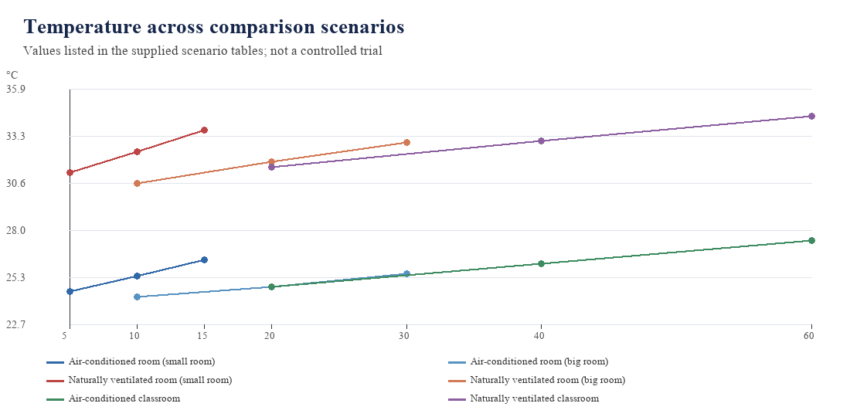
Fig. 6. Temperatures listed in the six supplied comparison tables. Each line is a separate setting; the plotted values are the supplied scenarios, not experimental curves.
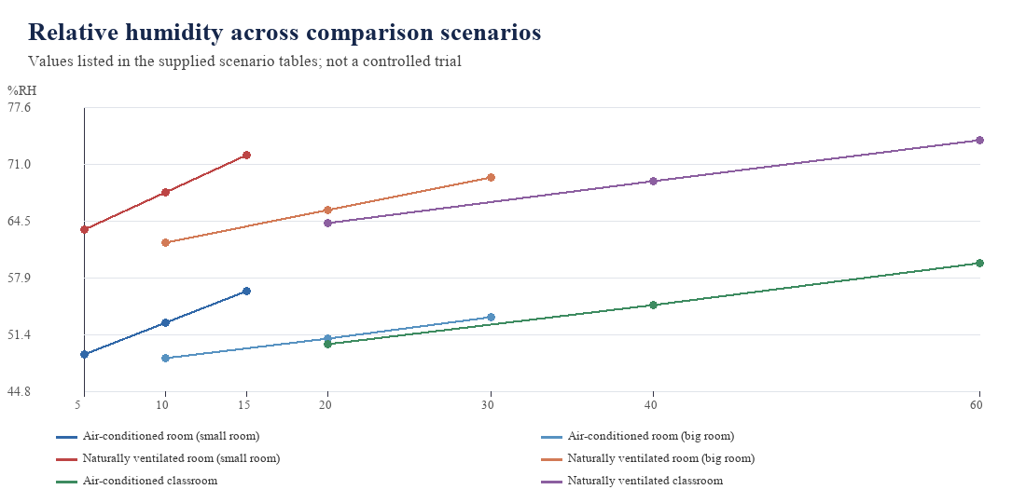
Fig. 7. Relative-humidity values listed in the six supplied comparison tables. Each line is a separate setting; the plotted values are the supplied scenarios, not experimental curves.
In simple terms, the comparison values list higher temperature and humidity in naturally ventilated settings than in air-conditioned settings. Within each setting, both usually rise across the occupancy points shown, while light stays close to 5 lux. MQ135 RS/R0 usually decreases across the listed cases. These patterns describe the supplied values only; they do not prove a cause or give a calibrated pollutant concentration.
V. IMPLEMENTATION STATUS
The software implementation is operational across the sensing and dashboard path: ESP32 firmware acquires DHT22, BH1750, and MQ135 values, organizes the current measurements, evaluates the predefined rules, and supplies the readings and current condition to the laptop dashboard. The dashboard presents live sensor values, rule-based status labels, fixed hints, and the AI Insights panel. The server-side AI feature sends the current readings to Qwen through Groq and displays the generated summary, suggestions, overall score, and focus-impact statement. Software refinements remain in progress to address occasional inconsistencies in AI-generated interpretations.
The project methodology also lists a software toolchain for developing and inspecting the controller-side logic. Arduino IDE is named for firmware development, compilation, and upload; the ESP32 board package supplies board support; sensor libraries provide interfaces to the sensing modules; and serial-monitor or debugging tools are listed for observing readings. The project documents do not identify specific library versions or a dashboard framework, so those implementation details are not added here.
Development item | Role in the project methodology
Arduino IDE | Develop, compile, and upload ESP32 firmware
ESP32 board package | Provide board support in the development environment
Sensor libraries | Support communication with the sensor modules
Serial monitor / debugging tools | Observe readings and assist verification
Classification logic | Process collected parameters and determine a condition

The implementation can be considered in terms of the complete user-visible path. First, the sensor modules provide readings for temperature, humidity, illumination, and the MQ135 resistance channel. Second, the ESP32 acquires and organizes these values. Third, the configured rules interpret the current set of readings. Finally, the laptop dashboard presents the values together with the resulting condition. The project description confirms these functional stages; detailed source-code structure, update frequency, and transport mechanism are not specified in the submitted project documents.
The system is implemented and operational, while refinements focus on improving the consistency of AI-generated interpretations with the sensor readings and rule-based status. The overall score and focus-impact statement are outputs of the AI service, not calibrated measurements or validated assessments of personal comfort or productivity.
No experimental results are reported because none were supplied. In particular, the project material does not show comparison of the DHT22 with a reference thermometer or hygrometer, comparison of the BH1750 with a reference light meter, or a controlled characterization of MQ135 behavior. It also contains no record of classification agreement, end-to-end delay, data loss, or extended run time. The absence of these values is not evidence of a failure; it means they cannot be stated as measured results in this paper.
VI. LIMITATIONS AND NEXT DEVELOPMENT STEPS
The current description is bounded by the information supplied for the project. Numerical rules and resulting category names are not documented in the source materials available for this paper. MQ135 RS/R0 values are therefore reported as readings rather than converted to a pollutant concentration. No claim is made that the prototype detects sound, computes personal comfort or focus, or learns from data.
The next documentation step is to record the final rule table directly from the completed firmware. For each rule, that record should identify the input field, comparison condition, resulting output label, and how simultaneous conditions are resolved. Publishing those details would make the classification reproducible while avoiding ambiguity about the meaning of a displayed condition. Until those values are confirmed, example thresholds would be misleading and have not been inserted.
It is also useful to state how the implementation treats incomplete inputs. If one sensor is disconnected or provides an unusable value, the final system should make clear whether the corresponding field is marked unavailable and whether the classification is withheld or computed from remaining values. The supplied material does not describe missing-reading behavior, so no current behavior is assumed in this paper. Recording the verified policy would clarify how a user should interpret the dashboard when not all readings are present.
A second step is to define a repeatable measurement check. Temperature, humidity, and light readings can be logged alongside suitable reference instruments under documented conditions. MQ135 resistance readings can be recorded consistently, while any conversion to a gas concentration would require a separately documented calibration procedure. Such a check would characterize readings; it should not be presented as evidence of health or productivity benefits.
A third step is to document dashboard behavior. Useful items include the exact names and units shown for every reading, the time represented by each update, how missing or invalid readings are handled, and how the rule-based condition is displayed. These are recommendations for a future report, not capabilities claimed for the current software. Reporting them would connect the implementation description to the experience of a user viewing the laptop dashboard.
Future evaluation can also separate sensor behavior from classification behavior. Sensor checks address whether the reported measurements are consistent under known conditions. Classification checks address whether the documented rules produce the expected label for chosen input values. Keeping these questions distinct would prevent an accurate display from being mistaken for a validated decision model, or a correct software rule from being mistaken for a calibrated sensor.
A practical evaluation record could include the date and environment of each reading session, the sensor values shown by the device, and corresponding reference values where an appropriate instrument is available. For the rule stage, selected input combinations could be compared with the output expected from the verified rule table. Such a record would make later claims traceable to observations. It is a proposed evaluation approach only; no results from this process are available in the supplied material.
The project may also benefit from a concise versioned record of hardware connections and software changes as the final refinements are made. Recording which sensor modules were connected, what fields appeared on the dashboard, and which classification rules were active would help readers reproduce the configuration tested. This recommendation does not presume that such versioning or a test log already exists.
A staged verification plan would help distinguish integration progress from measured performance. Component checks can confirm that each sensor field is acquired and represented as expected. An integration check can confirm that the complete set of readings reaches the laptop dashboard. A logic check can compare the final rule table with the condition shown for selected inputs. Finally, a runtime observation can document how the values and classification behave during a defined period. The project material does not say that these checks have been completed; the sequence below is a proposed record for final development.
TABLE XI. PROPOSED VERIFICATION RECORD
Check | Evidence to record
Sensor acquisition | Input and displayed value for each named sensor field
Dashboard integration | Whether all confirmed fields and condition are presented
Rule behavior | Verified rule, chosen input, and resulting classification
Runtime observation | Observation period and any missing or changing readings

This proposed verification sequence is not a claim of completed testing. It identifies the evidence that would support a later results section and make a future report more reproducible. Any numerical performance statement should be added only after the corresponding measurement has been performed and recorded.
The immediate completion work is the final software refinement identified by the team. A subsequent technical report can document verified classification rules, the precise dashboard fields and update behavior, and tests performed against suitable reference measurements. Those details should be added only after they are established in the final implementation.
VII. CONCLUSION
FreshAir Desk combines an ESP32 with DHT22, BH1750, and MQ135 sensing and presents temperature, humidity, light intensity, MQ135 RS, and RS/R0 readings on a live laptop dashboard. Current condition labels are rule-based, and an integrated AI Insights panel generates summaries, practical suggestions, an overall score, and focus-impact text from the sensor readings. The AI output is advisory and remains under refinement for consistency with the dashboard status. The supplied screenshot and comparison tables show readings and scenario values, but do not constitute a calibrated or controlled performance evaluation. Noise detection and a comfort score are outside the confirmed scope.
Further work can document the final rule conditions, refine the consistency between AI-generated text and the dashboard status, and evaluate the sensor and recommendation outputs using a clearly logged dataset. This paper distinguishes measured sensor readings, deterministic rule labels, and advisory AI-generated insights.
REFERENCES
[1] S. Shriram, V. Rajesh Kumar, et al., “Towards Healthier Workspaces: IoT-Based Thermal Comfort and Indoor Air Quality Monitoring,” International Conference on Computing, Communication and Sustainable Development (ICCoSD), 2025.
[2] T. Praveenraja and P. V. Manitha, “Integration of IoT-Based Air and Sound Pollution Monitoring with HVAC System for Enhanced Indoor Environment Management,” International Conference on Electronics, Computing and Communication Applications (ICOECA), 2025.
[3] M. Gabriel and T. Auer, “Indoor Air Pollution Estimation Using Machine Learning,” BauSim Conference Proceedings, 2022.
[4] D. Yeom, T. Kim, and S.-G. Yoon, “Productivity Prediction via Human Physiological Signals for an Optimum Thermal Environment,” CLIMA Conference Proceedings, 2022.
[5] G. Cicceri et al., “Smart Healthy Intelligent Room: Headcount through Air Quality Monitoring,” IEEE SMARTCOMP, 2020.
[6] F. Fanti et al., “An IoT-Based Smart Building Solution for Indoor Environment Management and Occupants Prediction,” Energies, vol. 14, no. 10, 2021.
[7] “Comparative Analysis of Indoor Environmental Quality and Self-Reported Productivity in Intelligent and Traditional Buildings,” Energies, vol. 16, no. 18, 2023.
[8] M. S. Bakare and K. Abubaker, “IoT-Based Indoor Environmental Monitoring System Using Multi-Parameter Sensing and ESP32-WROOM Integration,” Discover Electronics, vol. 3, article 6, 2026, doi: 10.1007/s44291-026-00157-7.
[9] H. S. Abdulaali, I. Usman, M. Hanafiah, M. Abdulhasan, M. Hamzah, and A. Nazal, “Impact of Poor Indoor Environmental Quality (IEQ) to Inhabitants’ Health, Wellbeing and Satisfaction,” International Journal of Advanced Science and Technology, vol. 29, no. 3, pp. 1–14, 2020.
[10] A. E. Afful, J. Ayarkwa, G. K. K. Acquah, and D. Osei-Asibey, “Enablers of Incorporating Indoor Environmental Quality (IEQ) Principles into Buildings,” Smart and Sustainable Built Environment, vol. 12, no. 1, pp. 38–59, 2023.
[11] O. Alsamrai, M. D. Redel-Macias, S. Pinzi, and M. Dorado, “A Systematic Review for Indoor and Outdoor Air Pollution Monitoring Systems Based on Internet of Things,” Sustainability, vol. 16, no. 11, article 4353, 2024.
[12] D. Assante and C. Fornaro, “An Educational IoT-Based Indoor Environment Monitoring System,” in Proc. IEEE Global Engineering Education Conference (EDUCON), 2019.
[13] A. Astolfi, A. Carullo, V. Fissore, G. E. Puglisi, G. Arcamone, P. Shtrepi, and P. Chiavassa, “Development and Metrological Characterization of a Multi-Sensor Device for Indoor Environmental Quality (IEQ) Monitoring,” in Proc. IEEE International Workshop on Metrology for Living Environment (MetroLivEnv), 2023.
[14] R. Bhardwaj, S. Kumari, S. N. Gupta, and U. Prajapati, “IoT Based Smart Indoor Environment Monitoring and Controlling System,” in Proc. International Conference on Signal Processing and Communication (ICSC), 2021.
[15] E. J. Biondo, “Real-Time Indoor Air Quality (IAQ) Monitoring System for Smart Buildings,” dissertation, Instituto Politécnico de Bragança, 2022.
[16] V. Di Leo, A. Speroni, G. Ferla, and J. D. Blanco Cadena, “Design and Validation of a Compact, Low-Cost Sensor System for Real-Time Indoor Environmental Monitoring,” Buildings, vol. 15, no. 19, article 3440, 2025.
[17] O. Diallo, J. J. Rodrigues, and M. Sene, “Real-Time Data Management on Wireless Sensor Networks: A Survey,” Journal of Network and Computer Applications, vol. 35, no. 3, pp. 1013–1021, 2012.
[18] V. I. Fissore, G. Arcamone, A. Astolfi, A. Barbaro, A. Carullo, P. Chiavassa, et al., “Multi-Sensor Device for Traceable Monitoring of Indoor Environmental Quality,” Sensors, vol. 24, no. 9, article 2893, 2024.
[19] W. Herra, A. Rabhi, H. Mastouri, H. Radoine, H. El Hadraoui, and A. Ennawaoui, “Design of Indoor Environmental Quality Monitoring System Using Model-Based Systems Engineering,” in Proc. IEEE Congress on Information Science and Technology (CiSt), 2023.
[20] J. Kim, S. Kim, S. Bae, M. Kim, Y. Cho, and K.-I. Lee, “Indoor Environment Monitoring System Tested in a Living Lab,” Building and Environment, vol. 214, article 108879, 2022.
[21] G. Marques and R. Pitarma, “Monitoring and Control of the Indoor Environment,” in Proc. 12th Iberian Conference on Information Systems and Technologies (CISTI), 2017.
[22] J. Peixe and G. Marques, “Low-Cost IoT-Enabled Indoor Air Quality Monitoring Systems: A Systematic Review,” Journal of Ambient Intelligence and Smart Environments, vol. 16, no. 2, pp. 167–180, 2024.
[23] A. Ramos, V. B. Jesus, C. Gonçalves, F. Caetano, and C. Silveira, “Monitoring Indoor Air Quality and Occupancy with an IoT System: Evaluation in a Classroom Environment,” in Proc. 18th Iberian Conference on Information Systems and Technologies (CISTI), 2023.
[24] W. Runathong, W. Wongthai, and S. Panithansuwan, “A System for Classroom Environment Monitoring Using the Internet of Things and Cloud Computing,” in Proc. International Conference on Information Science and Applications, 2017.
[25] J. Saini, M. Dutta, and G. Marques, “Indoor Air Quality Monitoring Systems Based on Internet of Things: A Systematic Review,” International Journal of Environmental Research and Public Health, vol. 17, no. 14, article 4942, 2020.
[26] J. Shah and B. Mishra, “IoT Enabled Environmental Monitoring System for Smart Cities,” in Proc. International Conference on Internet of Things and Applications (IOTA), 2016.
[27] I. L. Niza, A. M. Bueno, and E. E. Broday, “Indoor Environmental Quality (IEQ) and Sustainable Development Goals (SDGs): Technological Advances, Impacts and Challenges in the Management of Healthy and Sustainable Environments,” Urban Science, vol. 7, no. 3, article 96, 2023.
[28] T.-W. Tsang, K.-W. Mui, L.-T. Wong, A. C.-Y. Chan, and R. C.-W. Chan, “Real-Time Indoor Environmental Quality (IEQ) Monitoring Using an IoT-Based Wireless Sensing Network,” Sensors, vol. 24, no. 21, article 6850, 2024.
[29] Z. Wang, Z. Chen, I. Shahid, Z. Asif, and F. Haghighat, “Indoor Air Quality Assessment through IoT Sensor Technology: A Montreal–Qatar Case Study,” Atmosphere, vol. 16, no. 5, article 574, 2025.
[30] R. Zahariev, “The Impact of Interior Lighting on Health and Visual Comfort,” SETSCI Conference Proceedings, 2025.

